**Inventory and Asset**

**Management**

Project Proposal

By

**Mr. Nathawut Supavananusorn 542115020**

**Mr. Tanadol Parn-ong 542115021**

Department of Software Engineering

College of Arts, Media and Technology

Chiang Mai University

Project Advisor

________________________

**Dr. Prompong Sugunnasin**

**Document History**

|  |  |  |  |  |  |  |
| --- | --- | --- | --- | --- | --- | --- |
| **Document Name** | **Version** | **Status** | **Date** | **Viewable** | **Reviewer** | **Responsible** |
| **Documents** | | | | | | |
| Inventory and Asset Mangement_v0.1.docx | Create Chapter One  -Abstract  -Introduction and Background | Release | 5 May 2015 | NS, TP, PS | NS,TP | TP |

**\*NS = Nathawut Supavananusorn**

**\*TP = Tanadol Parn-ong**

**\*PS = Dr. Prompong Sugunnasin**

**Abstract**

Currently, the technician in many organizations usually have problems with the division of tasks and responsibilities. Which these problems affect to delay repairing and follow-up. These problems can cause customer dissatisfaction is huge.

In this project, we plan to develop the web application for support repairing management. Inventory and Asset Management is a system that helps the user to manage and divide the works to each of the technicians equally. Inventory and Asset Management will made the technician easy to view work and progress of the repair. This system will help the user to comfortable so much. The system provides the user to identify and verify spare parts that can use it or it had broken and view the lifetime of spare parts.

User can use Inventory and Asset Management for repairing management. The technician has divided up the task and works from system equally. The technician can check his task and progress of the repair work.

Contents

**Chapter One | Introduction and Background** 5

# **Chapter One | Introduction and Background**

Nowadays, CAMT’s durable articles management will have IT Staff who manages durable articles such as Projector, Computer, and other tools. Every year, CAMT has been recorded durable articles that are out of order and plan to purchase new durable articles to replace durable articles to expire or durable articles that are out of order. Currently, CAMT uses Microsoft Excel to manage and record the durable articles information. CAMT’s durable articles will have an IT Staff to Manage durable articles or repair durable articles that are out of order. There will be a report to fix the durable articles from other staffs who use durable articles or durable articles owner. In the process of the repair, staffs will fill out a paper form and submit a request to the IT Staff.

From the foregoing, CAMT’s IT Staff spend much time for information recording, durable articles information management, planning to purchase a new durable articles that will replace durable articles to expire or durable articles is out of order, and difficult to analyze the durable articles brand that’s usually out of order that will be a part of planning to purchase new durable articles. In addition, the repair report has the process for repair many durable articles and repair durable articles for a long time. The IT Staff had problems. The IT Staff had an issue about the unequal distribution of work that made delays in repairing the durable articles as well.

Inventory and Asset Management system can solve this issue that has the durable articles management system (add, edit, and delete durable articles information), The MIS system for reports the durable articles brand that’s usually out of order, reports durable articles to expire, and static of durable articles repair per month. Which this system can help IT Staff to Manage durable articles information and plan to purchase the durable articles easily. There is also a system repair by a report on the website. The repair work is distributed to IT staff in equal amounts in each one. Moreover, there is notification for update the status of repair system by email.

# **Chapter Two | Literature Review**

## **2.1 Business Review**

### 2.1.1 iSoftService [1]

iSoftService is an application about repair management system. This system are used by the repair center. This system help to manage the product repairing, and notify to technicians about their work. iSoftService supports major features as follows,

1. This system provides technicians to manage their repairing works.
2. This system provides technicians to record repairing works.
3. This system provides technicians to find their works.
4. This system provides technicians to check the progress of repairing works.

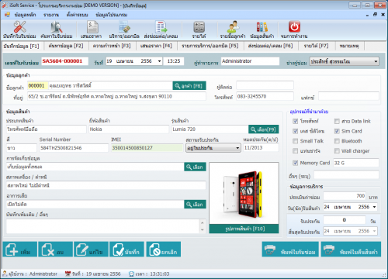

*Figure 1 iSoftService main page Demo Version*

Figure 1 shows the interface of item information page where users can input item information that is repaired. On the right side of Figure 1 provide the user to select an item that is repaired and to display after sales service time.

Pros

iSoftService provide several functions about repairing system for technicians such as record repairing information, find repairing information, calculate income, and other functions. This system provides repairing collaboration between departments in the service center.

Cons

Users must spend a lot of money for purchasing the iSoftService license. This system has weakness because technicians spend time very much to distribute works of each technician equally. iSoftService user interface has function complexity, so this system is difficult to use for beginning user.

### 2.1.2 Service Center [2]

Service Center is developed for the organization, which is a service center for repair and installation, such as appliance repair service center, PC repair shop, and mobile repair shop. This system is convenient for the general repair shop. Service Center supports major features as follows,

1. This system provides the user to record service and repair work.
2. This system provides the user with search product, the status of repair works.
3. This system provides interaction between system and user with friendly interactive.
4. This system provides the user to check information and the progress of repair works.

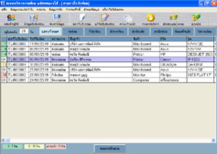

*Figure 2 Service Center main page*

Figure 2 shows the interface of the main page where users can view and manage repair information. On the top side of Figure 2 provide the user to use the menu for repair management.

Pros

Service Center is an application that provides convenient to repairing technicians. This system provides basic functions to manage repair information such as the user account and user permission, search information, and other essential functions, which are appropriate general repair shops.

Cons

This system needs to spend a lot of money for purchase a license for use. This system has obsolete repair system that technicians must spend too much time on repair management and distribute works of each technician equally. Service Center is hard to use for the user who does not have experience about repair management because there functions a diverse and scattered in a single system.

## **Technology Review**

### .Net MVC [3]

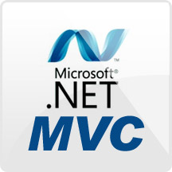

*Figure 3 .Net MVC*

**Technology Detail**

MVC is 1 of 3 ASP.NET programming models. MVC is a framework for building web application using MVC design pattern. The concept of MVC design pattern will manage (separate) task and element in application to easy for building and development. The MVC separation helps you manage complex applications because you can focus on one aspect a time. MVC made you test an application easily.

**Alternative technology**

- PHP, JSP

**The selection of this technology**

. - ASP.NET can build dynamic web application and web service.

- ASP.NET support the MVC development model.

### MS SQL Language [4]

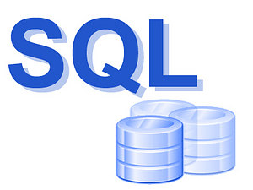

*Figure 4 MS SQL Language*

**Technology Detail**

SQL or Structured Query Language is a language that use for manage database. SQL is a standard language for using and accessing databases. It is the open system which we can use SQL command with all database. SQL language is easy to understand, uncomplicated and a high performance. SQL can run complex queries using only a few commands.

**The selection of this technology**

- Using standard SQL it is easier to manage database systems

- SQL Queries can be used to retrieve large amounts of records from a database quickly and efficiently.

### CSS [5]

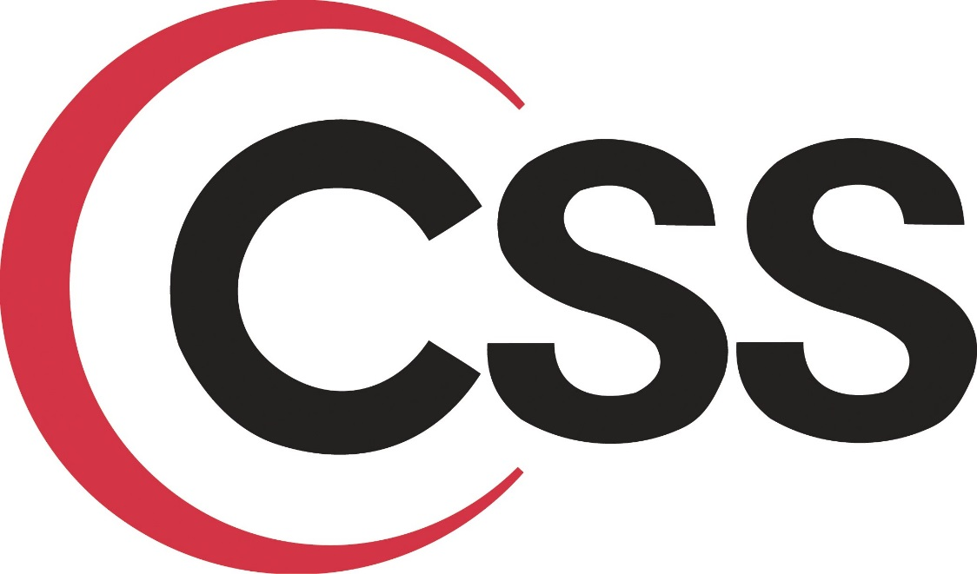

*Figure 5 CSS*

**Technology Detail**

CSS or Cascading Style Sheets is a language with a specific Syntax form and was standardized by W3C (World Wide Web Consortium), as well as HTML and XHTML documents. CSS is used for decorative HTML / XHTML to look colorful characters, backgrounds, borders, spacing, etc. With custom features to the Element of HTML.

**The selection of this technology**

- Automatically make it to every page of your website.

- CSS is considered a clean coding technique.

- Easier to maintain and update.

- Greater consistency in design.

- Ease of presenting different styles to different viewers.

### HTML [6]



*Figure 6 HTML*

**Technology Detail**

HTML or Hypertext Markup Language is a standard language for using design web pages. HTML use Tag for define HTML displaying. HTML language is a Markup language that use for building web pages. HTML has a template from SGML (Standard Generalized Markup Language) for to understand and easy to learn. Currently being developed and standardized by the World Wide Web Consortium (W3C).

**The selection of this technology**

- Every browser supports it.

- Needed for basically everything other than text.

- Easy & Simple to learn and use.

- Easy to maintain.

- Free

### JavaScript [7]

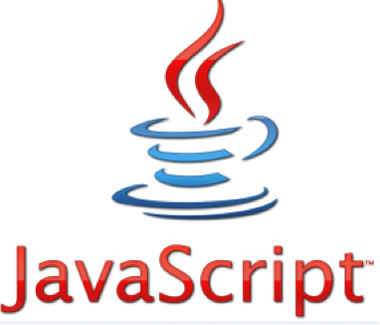

*Figure 7 JavaScript*

**Technology Detail**

JavaScript is the programming language for building web application. JavaScript use to program the behavior of web pages. All modern HTML pages are using JavaScript. JavaScript can help web pages to interesting by add movement to web pages. JavaScript made web application to response the user more.

**Alternative Technology**

- Haxe

**The selection of this technology**

- JavaScript is executed on the client side.

- Relatively easy language.

- Relatively fast to the end user.

- Extended functionality to web pages.

### Cloud computing [8]

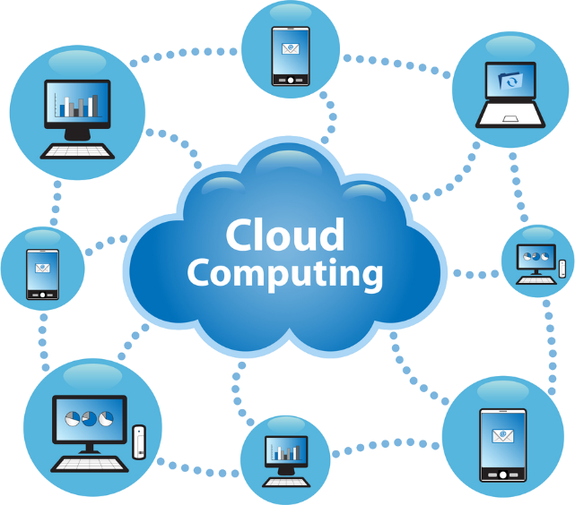

*Figure 8 Cloud computing*

**Technology Detail**

Cloud Computing is a technology that uses internet to connect to the servers to maintain data and applications. Cloud computing allows users use applications without installation. They can access their files by the computer with internet access. Because every application is on the cloud system we can access to the application by using internet. Cloud computing allows for much more efficient computing by centralizing data storage.

**The selection of this technology**

- Unlimited resources: Cloud computing providers can provide more resource when resources are insufficient as the demand increases.

- Maintenance: Cloud computing supports easy maintenance. The administrator can access to the server from different places.

- Security: Cloud computing providers devote resources to security. Users can rely on their service providers for secure data storage and transfer.

## **Development Tool Review**

### MS SQL Server [9]

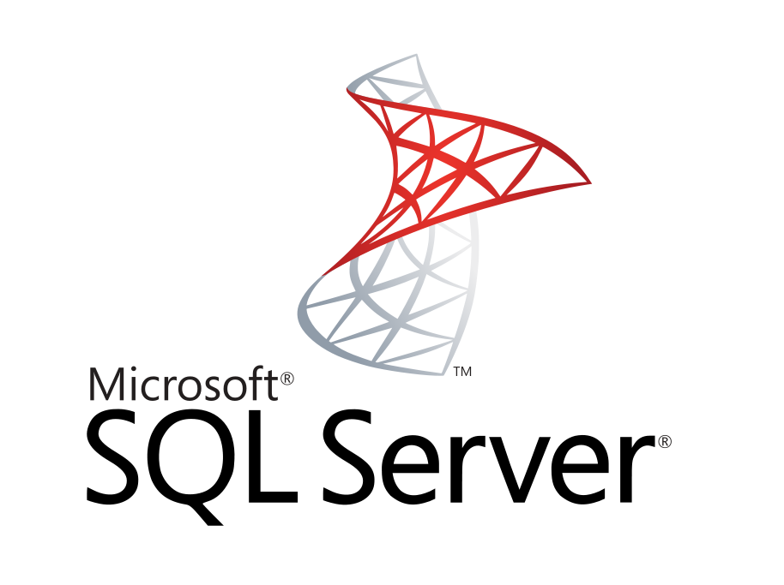

*Figure 9 MS SQL Server*

**Development Tool Description**

Microsoft SQL Server is an information platform and the database server that provide technologies for organization. It provides the tools to manage and develop the software that helps to function effectively. And provides insights into the complex through the use of BI users are handled manually. Microsoft SQL Server is a complete platform and integration with other databases to create value from their IT skills and resources to achieve maximum benefit. Performance and flexibility of the IT department. Applications and create new applications. Flexible working quickly.

**Alternative Technology**

- SQLite

- MySQL

- Microsoft Access

**The selection of this technology**

- Easy to integrate with development tool.

- Provide many features and security.

- Flexible for using and manage via other tool.

### MS Visual Studio [10]

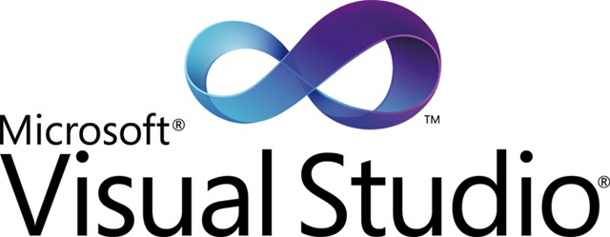

*Figure 10 MS Visual Studio*

**Development Tool Description**

MS Visual Studio is Integrated Development Environment that is developed by Microsoft. MS Visual Studio is the tools that provide developer to develop programs, web applications and web services.

**Alternative Technology**

- FoxPro

- Visual Studio Online

**The selection of this technology**

- Speed Deployment and Updates.

- Build web applications like a professional designer.

- Create a custom application

- Build a better application faster.

### Photoshop [11]

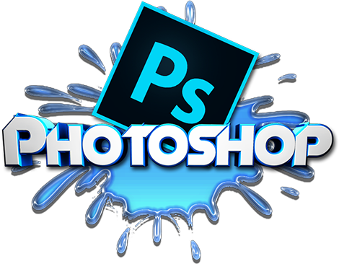

*Figure 11 Photoshop*

**Development Tool Description**

Photoshop is a raster graphics editor. Photoshop has many tools for design such as manipulate, crop, resize, and correct color on digital photos.

**Alternative Technology**

- GIMP (cross-platform).

- Paint.NET (Windows only).

**The selection of this technology**

- Edit images easier.

- More image effects.

- Previously used.

- Supported animation.

- Can save in several image file.

### C:\Users\nathawut\AppData\Local\Microsoft\Windows\INetCache\Content.Word\logo-vertical-light-735b5657.pngMandrill [12]

*Figure 12 Photoshop*

**Development Tool Description**

Mandrill provide the user to flexible. Mandrill provide the user to send mail from more than one domain within a single Mandrill account, with no additional fees. Mandrill can make the transition to a new dedicated IP easier by automatically ramping up sending over a 30-day period. Mandrill is a scalable and affordable email infrastructure service. Mandrill has servers around the world which makes to send mail faster.

**Alternative Technology**

- Java API

- .NET API

- Python API

- Google API

**The selection of this technology**

- Mandrill authenticates your mail automatically.

- Mandrill's IPs are automatically registered for feedback loops with ISPs.

- Mandrill can make the transition to a new dedicated IP easier

- Mandrill provide user send from more than one domain within a single Mandrill account.

### Window Azure [13]

**Development Tool Description**

Window Azure is a cloud computing platform, which has been developed by Microsoft. Window Azure is used to build, deploy and manage applications and services via a global network of Microsoft-managed datacenters. Window Azure provides Platform as a Service and Infrastructure as a Service also, it supports different programming languages. Platform as a Service use for providing customers rent tools, libraries, storage, operating system and network capacity from the provider. Infrastructure as a Service use for providing customers rent virtual machine, storage, hardware and server from the provider.

**Alternative Technology**

- Amazon cloud drive

- Iris cloud computing

**The selection of this technology**

- we use Cloud service of Window Azure because it is Platform as a Service. Cloud service is containers of hosted applications. These applications can be the web application or private processing engines for works.

- Cloud computing renter can pay an amount of money that depend quantity of resources.

- Window Azure deploy software that was develop by using .Net framework is easily.

- Rate of downtime is less because Microsoft guaranteed rate of uptime is 99.9%.

### 2.3.6 Internet Information Service (IIS) [14]

**Development Tool Description**

Internet Information Service (IIS) is a web server developed by Microsoft. It is a secure, easy-to-manage, modular and extensible platform for reliably hosting websites, services and applications and provides a set of Internet-based services for servers including HTTP, HTTPS, FTP, FTPS, and SMTP.

**Alternative Technology**

- Apache Tomcat

- AOLserver

**The selection of this technology**

- Internet Information Service works with .Net, both of which are developed by Microsoft.

- Internet Information Service is a part of the Window operating system. It is easy to using

### 2.3.7 Bootstrap [15]

**Development Tool Description**

Bootstrap is open source which it is hosted, developed and maintained on GitHub. Bootstrap can help web developer to faster and easier. It's made for folks of all skill levels, devices of all shapes, and projects of all sizes. Bootstrap uses HTML, CSS, and JS framework for developing responsive, mobile first projects on the web.

**Alternative Technology**

- Foundation

- Gumby

**The selection of this technology**

- Bootstrap is a sleek, intuitive, and powerful front-end framework.

- Bootstrap easily and efficiently scales your websites and applications with a single code base.

- It’s extensive and beautiful documentation for HTML element.

# **Chapter Three | Quality Standard**

## **3.1 ISO 29110 for Very Small Entity (VSE**)

ISO 29110 is a guide applies to a very small entity, enterprise, organization, department or project up to 25 people dedicated to software development. The guide provides project management and software implementation process which integrate practice based on the selection of ISO/IEC 12207 systems and software engineering-software life cycle process and ISO/IEC 15289 software engineering-software life cycle process guideline for the content of software life cycle process information product (documentation) standards elements

### 3.1.1 Project management process

The purpose of the software management process is to establish and carry out in a systematic way the task of the software implementation project which allows complying with the project’s objectives in the expected quality. Time and cost

**Selected process**

3.1.1.1 Project planning process

3.1.1.2 Project plan execution process

3.1.1.3 Project assessment and control process

3.1.1.4 Project closer process

### 3.1.2 Software implementation process

The purpose of the software implementation process is the systematic performance of the analysis, design, construction, integration and test actives for new or modified software products according to the specified requirements.

**Selected process**

3.1.2.1 Software implementation process

3.1.2.2 Software requirement analysis process

3.1.2.3 Software architectural design process

3.1.2.4 Software construction process

3.1.2.5 Software integration process and test process

3.1.2.6 Software delivery process

# **Chapter Four | Project Plan**

## **4.1 Motivation**

Based on experience, we found several problems of repairing management. Firstly, when repair work is not same, the technician do work unequally. The technician cannot check their repair work, find repair work and view the progress of repair work.

## **4.2 Aim and objectives**

### 4.2.1 Aim

- To develop web application which support to view the progress of repair, the division of task for technicians, and basic management for administrator.

- To develop web application which help view progress of repair, view personal task and report of repair for technician.

- To develop web application which help to view notification of repair for staff.

### 4.2.2 Objectives

To develop a web application that provides more convenience to the users by invent more function for support technicians within an organization.

## **4.3 Deliverables and limits**

Mandrill can send 12000 mails per month.

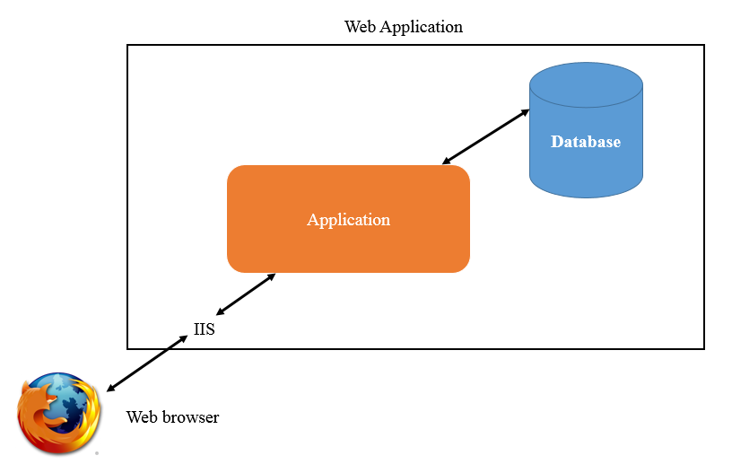4.3.1 System Architecture

The architecture of “” system is shown in Figure “”. It is the web application, which the user can access by using a web browser. The system uses IIS for interchanging data between the web browser and the application.

4.3.2 Deliverables

-Proposal

-Project plan

-Software requirement specification

-Software design document

-Testing document

-Traceability record

-Software quality assurance document

-Certification client and server system

-Video clips for demo program

-Poster A1 for presentation

4.3.3 Limits

- Internet connection is required for using this system.

- Users need to log in before using this system.

- The alert service is not provided when users are not logged into the system or the user’s application is in offline mode.

- This web application is tested only on Firefox only.

## **4.4 Future Work**

The license can be implemented for repairing computer. This system can be used in any computer service and repair center that would like to use the system to support technician and repair center. We hope our system can help the technicians to manage repair work within an organization efficiently.

## **4.5 Software Process**

*Iterative development model*

Iterative development model is one of the software development models which evolves from waterfall model. By changing process flow from step to step into iterative step. When the process flows into iterative, the process will start from the first step then go to the next step till the last. After that, the process will back to the first step and start again. The iteration will be repeat until all processes planned are complete then out from the loop and go to next main phase.

**Proposal phase:** This phase is about creating a proposal for “” system.

**Document plan phase:** This phase is about document for planning and designs the overall system from requirement given by the user. Iterative all features: This phase is about separate system into many features and then iterative create all feature from the first feature till the final feature. For this phase, it will be divided into 4 phases. There are;

**- Plan:** Planning the method for creating and test each feature.

**- Implement:** Implementing and coding each feature.

**- Test:** Testing and fixing each feature.

**- Review:** Reviewing and maintaining each feature to meet the feature plan.

**System test phase:** This phase will integrate all features into one system and then create test document from system testing.

**Deploy phase:** This phase is about deploying the whole system to server and use as a regular mobile application.

## **4.6 Schedule & Milestones**

**There are three types of users:**

- Administrator

- Technician

- Reporter

4.6.1 Features

**Feature#1** Account management

**Description:** This feature provides the user to register and create account for use this system  
 **User:** Administrator, Technician, Reporter

**Details:**

* 1. **Administrator:** Administrator can add technician/reporter accounts.
  2. **Administrator/Technician/Reporter** : Administrator/Technician/Reporter can update his account information.
  3. **Administrator:** Administrator can delete technician/reporter accounts.

**Feature#2** Login/Logout System

**Description:** This feature provides the user to sign-in by username and password for use this system  
 **User:** Administrator, Technician, Reporter

**Details:**

* 1. **Administrator/Technician/Reporter:** Administrator/Technician/Reporter can log in to the system.
  2. **Administrator/Technician/Reporter:** Administrator/Technician/Reportercan log outfrom the system.

**Feature#3** Product management

**Description:** This feature provides the user to manage product or spare parts that use for repair.

**User:** Administrator, Technician

**Details:**

* 1. **Administrator:** Administrator can add products to the system.
  2. **Administrator:** Administrator can update product information in the system.
  3. **Administrator:** Administrator can delete products in the system.

**Feature#4** Reporting System

**Description:** This function provides the user to report about repair works to the technicians.

**User:** Administrator, Technician, Reporter

**Details:**

* 1. **Reporter:** Reporter can report dilapidated product to the system.

**Feature#5** Tracking system

**Description:** This feature provides the user to follow-up repair work for check progress of repair work.

**User:** Administrator, Technician, Reporter

**Details:**

* 1. **Technician:** Technician can view his dilapidated product report in the system.
  2. **Reporter:** Reporter can view his dilapidated product report in the system.
  3. **Technician:** Technician can update repairing product status in the system.
  4. **Technician:** Technician can send a email to Reporter when repairing product status is changed.
  5. **Reporter:** Reporter can limit access of repairing product status email.

**Feature#6** Summary report system

**Description:** This feature provides the user to

**User:** Administrator, Technician, Reporter

**Details:**

# **Chapter Five | References**